Gateways | Lookup Latency (Time taken for Get + Reply)
1 | N/A  (No gets without authentication during join) | 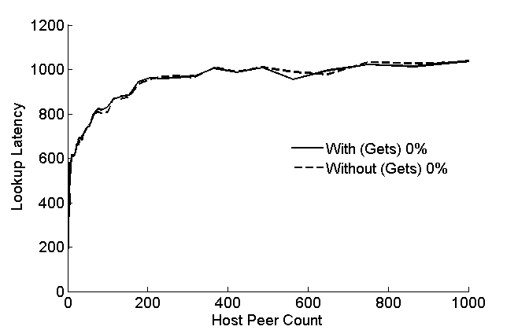
10% | N/A  (No gets without authentication during join) | 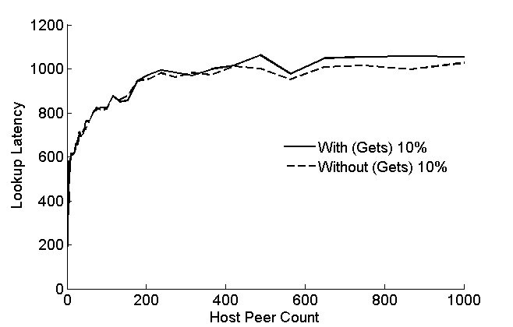
50% | N/A  (No gets without authentication during join) | 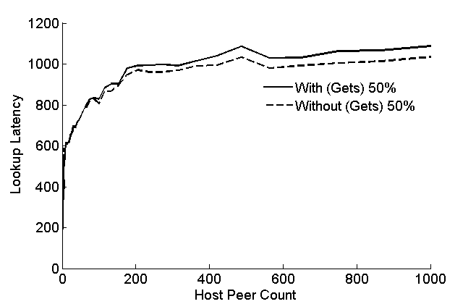
90% | N/A  (No gets without authentication during join) | 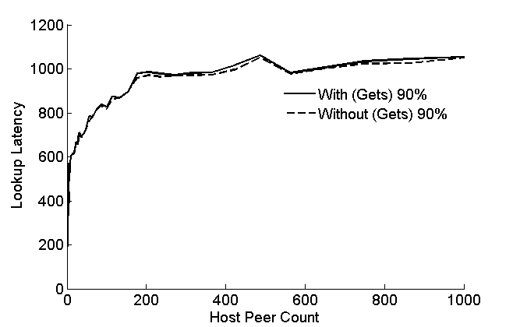
100% | N/A  (No gets without authentication during join) | 